Meghan Ng

GEOG 360

Project: Data, Near and Far

3 November 2016

**1.**

meghanng

**2.**

<http://tasks.hotosm.org/project/1491#task/74>

**3.**

<http://hdyc.neis-one.org/?meghanng>

**4.**

<http://www.openstreetmap.org/edit#map=16/-1.3101/-78.5858>

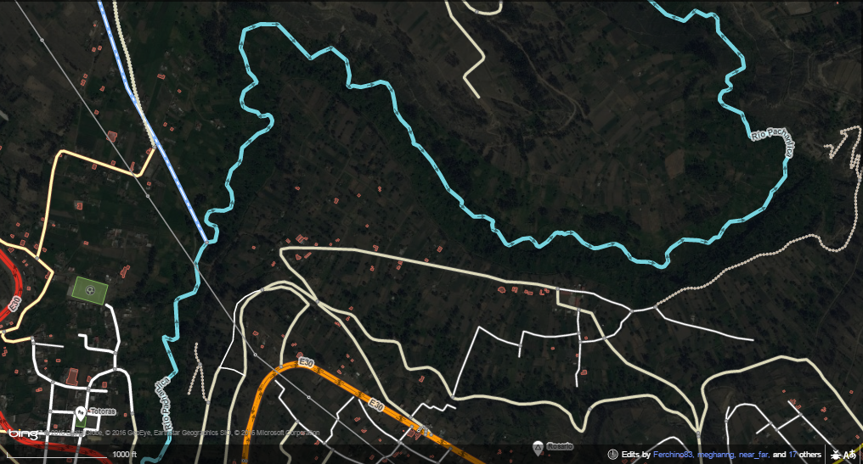

**5.**

This project was so fun to work on! I feel like I’ve done some good things for the world today. I wish I had known about OpenStreetMap and the Humanitarian OpenStreetMap Team sooner – it’s simple and so easy to use.

In the picture above, I changed the structure of the river so that it would be more accurately represented as it naturally is on the basemap with curves and everything. Originally, it was just straight lines that generally made out the shape of the river. This was peculiar to me – why was it drawn as an estimate of the river, when the river was clearly shown on the basemap? Was it because the original mapper of the river want to quickly sketch the layout of the river due to the lack of time he/she had surrounding the emergency? I decided to make the curves of the river more accurate to reflect the actual phenomenon, in a way that I’m sure that rivers in more well-known cities would be drawn.